Managing Users, Groups, and Sudo Privileges? SSH Security & Key-Based Authentication? Understanding SELinux & AppArmor

1.Create a new user called streamer and a group called musicfans on your Linux system, then add streamer to the musicfans group. Verify the group membership using the id command.

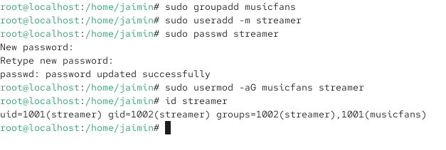
2.Give your current user sudo privileges by editing the /etc/sudoers file using visudo. Test by running a command that requires sudo, such as updating the package list.

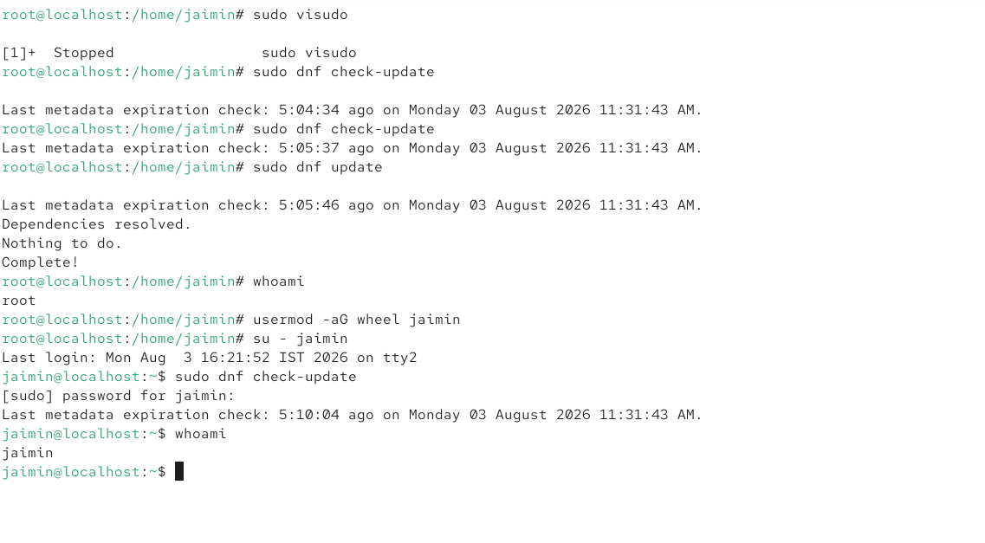

3.
Set up SSH key-based authentication: generate an SSH key pair using ssh-keygen, then copy your public key to a remote Linux server (or a local VM) using ssh-copy-id. Disable password authentication for SSH in /etc/ssh/sshd_config and restart the SSH service.Hint: Look for the PasswordAuthentication setting in the SSH config file.

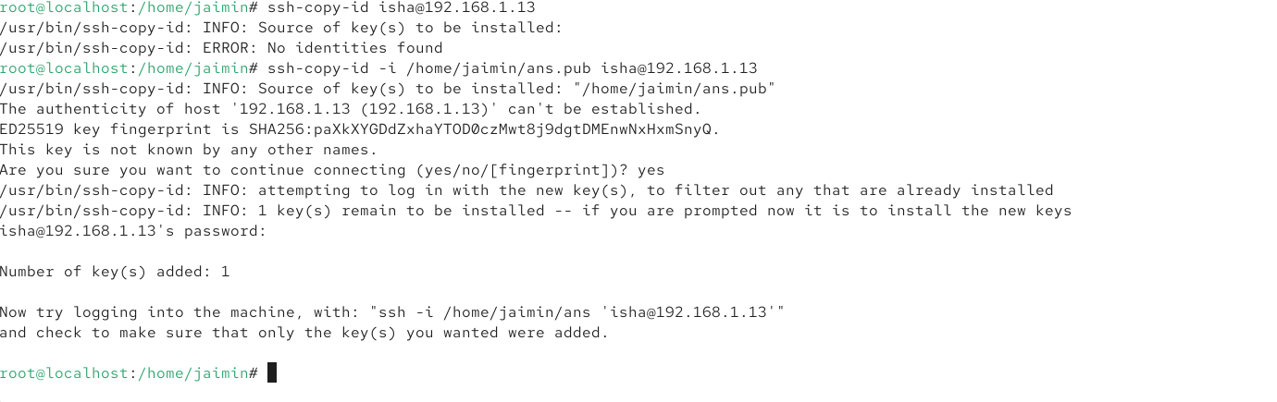
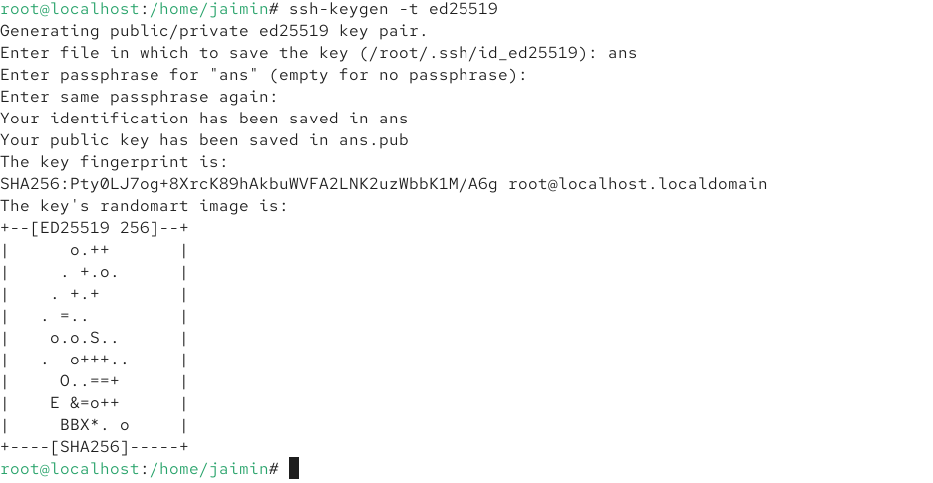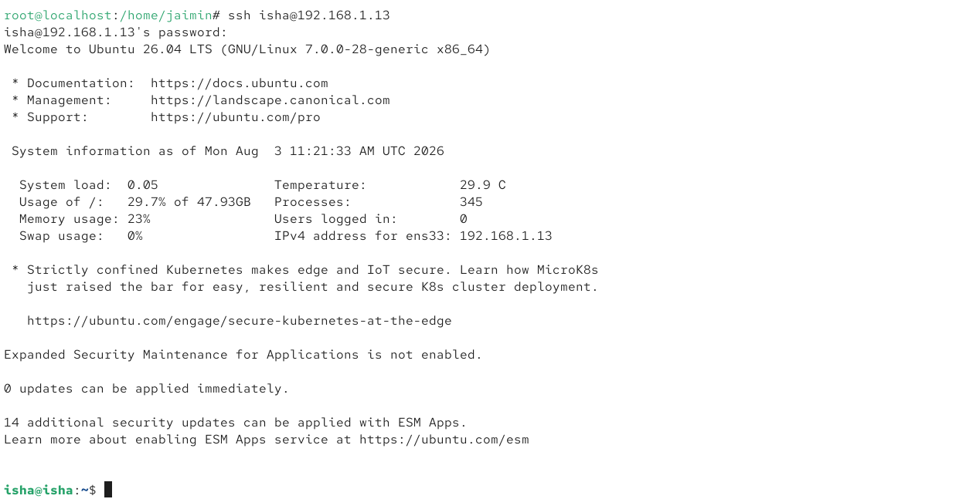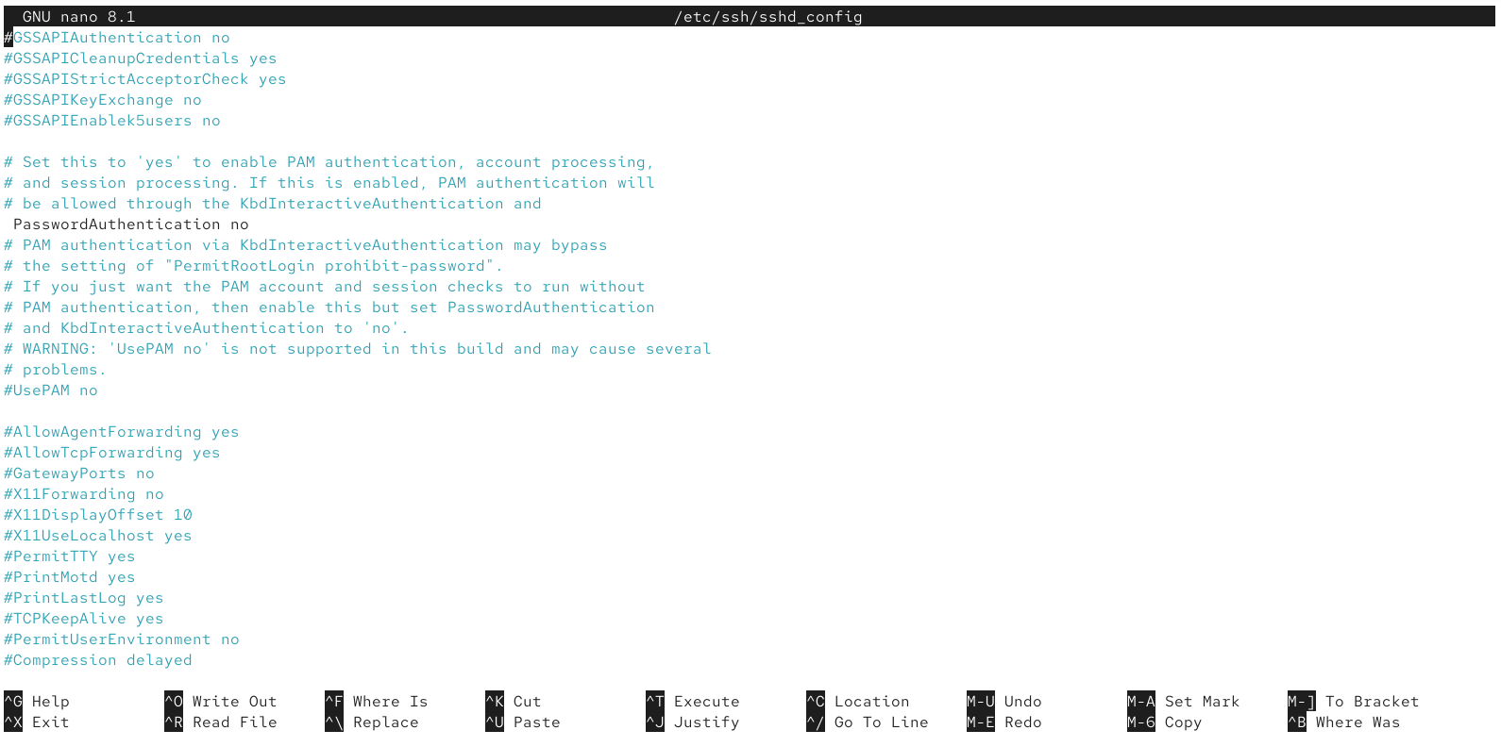

4.Check if SELinux or AppArmor is enabled on your system. If SELinux is active, use the getenforce command to display its current mode, and switch it to permissive mode. If AppArmor is active, list all enforced profiles using sudo apparmor_status
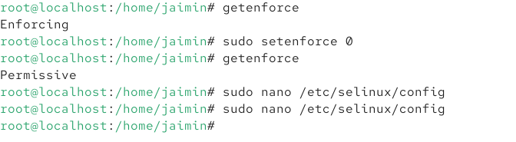
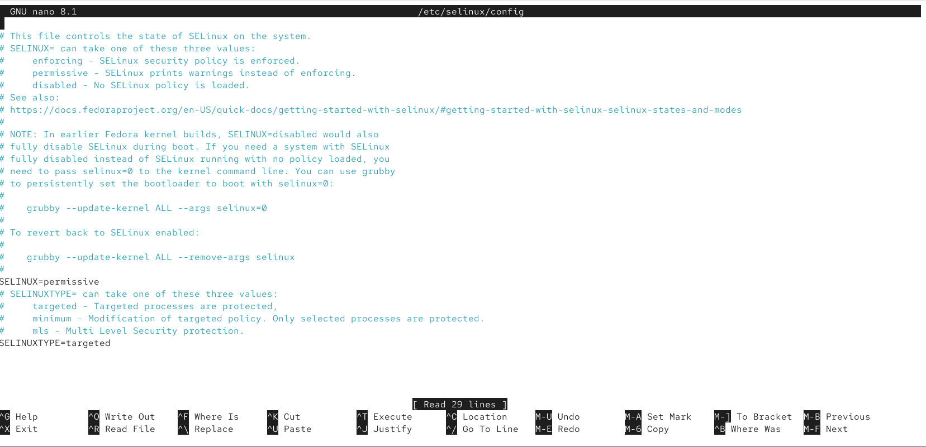
5.Use ChatGPT to explain the difference between SELinux and AppArmor in one paragraph, then write a summary in your own words and mention one real-world app (like Zomato or Paytm) that would benefit from these security modules.
Difference between SELinux and AppArmor
SELinux and AppArmor are Linux security modules that provide Mandatory Access Control (MAC) to restrict what applications and users can access. SELinux uses security labels and detailed policies to control access to files, processes, ports, and other resources, while AppArmor uses application-specific profiles that define what each program is allowed to access. SELinux is commonly used in RHEL, CentOS, and Fedora, whereas AppArmor is commonly used in Ubuntu and SUSE. Both help limit the damage that could occur if an application is compromised.
Summary in my own words
In simple terms, SELinux and AppArmor act like security guards for Linux applications. They make sure that even if a program is hacked, it cannot freely access the entire system. SELinux provides more detailed and label-based control, while AppArmor is generally easier to configure using application profiles.
Real-world example: Zomato
An application like Zomato could benefit from SELinux or AppArmor on its backend servers. For example, the web server could be allowed to access only the application files and required network ports, while being prevented from accessing sensitive system files or database credentials. If an attacker exploited a vulnerability in the web application, the security module could restrict the attacker's access and reduce the possible damage.

